TELEPHONE BOOK PROJECT

Project Discription: This is a telephone book Project that helps us to add new persons informations, update their informations or delete the persons to our telephone book.

Project Details

Firstly I have created a database which is named serkansipahiProject to insert my data to my

Project from here

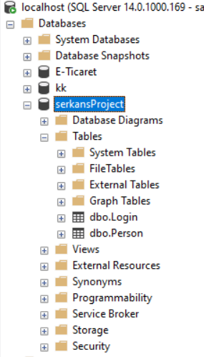

Than I have entered the data types that I will use in my Project

tablo içeren bir resim

Açıklama otomatik olarak oluşturuldu

Than I have connected my Visual Studio Project whit my Sql Database after that I have designed my authentication form and menu form like that.

Authentication Form

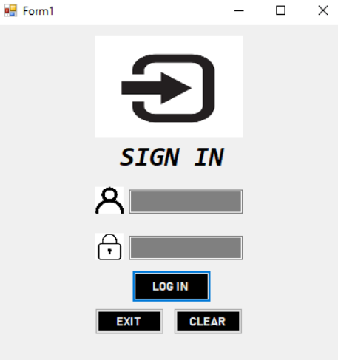

Menu Form

metin, ekran görüntüsü, ekran içeren bir resim

Açıklama otomatik olarak oluşturuldu

Run The Program

When we run the program we come face to face with a sign in screen. If we enter the username and password correct program will direct us to the menuform.

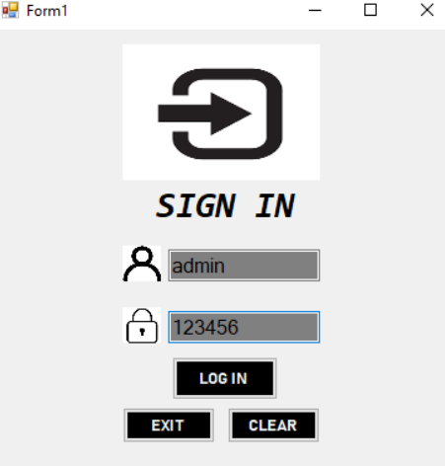

But if we enter the username or password wrong it will give an error like that

metin içeren bir resim

Açıklama otomatik olarak oluşturuldu

Also if click on the clear button it will clear all the writtens

metin içeren bir resim

Açıklama otomatik olarak oluşturuldu

After we have succesfully enetered program we will see the datas about persons like that;

tablo içeren bir resim

Açıklama otomatik olarak oluşturuldu

Here we can add new person, we can update the added person, we can delete the added person or we can clear the writtens in the blanks.

-İf we want to update person firstly we should write the ID and than we should enter the informations that we wanted to change and than when we clicked the Update button person will be updated.

-İf we want to delete a person again we should enter the ID of person than when we clicked on the Delete button person will be deleted.